**5-2 Final Project Part I Submission (ConsoleRegisterStudent)**

Marco Chan

Southern New Hampshire University

IT-230: Software Develop with C#.NET

Sabahudin Tricic

October 6, 2024

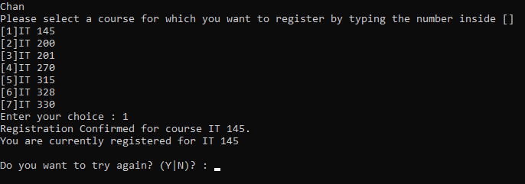

The student selects a course by entering an integer. All registered courses are then displayed.

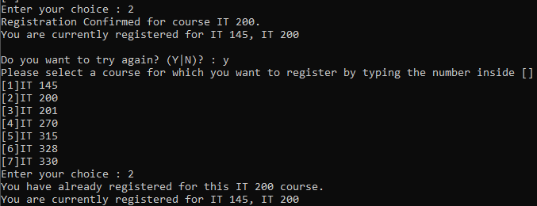

Registration is not allowed more than once for the same course.

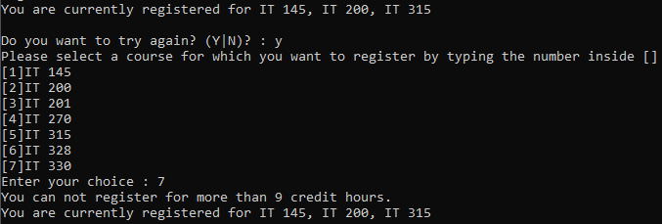

Courses have three credit hours each, and the student cannot register for more than nine credit hours.

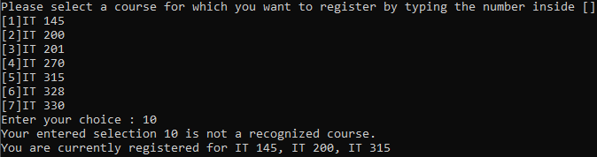

Registration of courses outside of the given list is not allowed.



The program terminates only when the student requires it.

## Source Code

int ValidateChoice(int choice, int firstChoice, int secondChoice, int thirdChoice, int totalCredit)

{

if (choice < 1 || choice > 7) // previously choice < 1 || choice > 70

return -1;

else if (choice == firstChoice || choice == secondChoice || choice == thirdChoice) // previously (... && ... && ...)

return -2;

else if (totalCredit >= 9) // previously totalCredit > 9

return -3;

return 0; // previously -4

}

The ValidateChoice function contained four errors that I corrected. First, the program mistakenly determined that choices outside 1-70 were invalid instead of 1-7. Secondly, when checking if a choice was already registered, it checked if the choice was the same as all previously registered courses when the choice only needed to match one previously registered course. Next, the program did not prevent registration when the student already had nine credit hours, as it was checking if the student had more than nine credit hours. Finally, when the choice was valid, it returned the wrong case number for a valid choice.